# Response to Review of Project 1 for Intel® Edge AI for IoT Developers Nanodegree

# Student: Reginald D. Cobb

I have revised my code as described below for the Required items. I have included the original comments and then revised code snippets from Visual Studio Code. I’ve also updated the code modules in GitHub.

## main.py

### Reviewer Comments

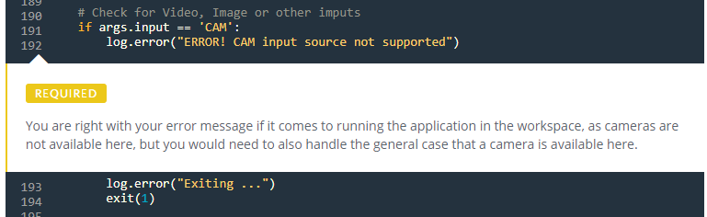

### Revision

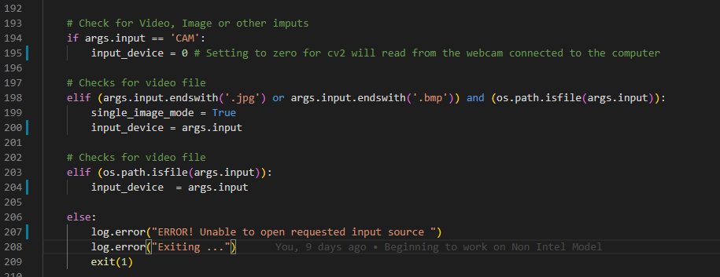

## Inference.py

1. Reviewer Comments

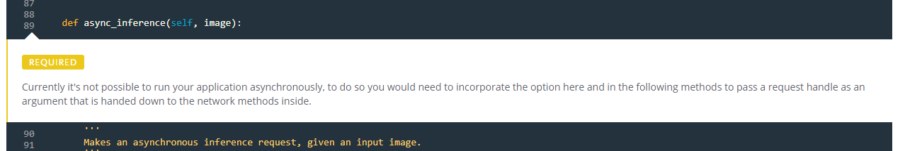

1. Revisions
   1. I also change corresponding code in the main.py and used request_id throughout both inference.py and main.py.

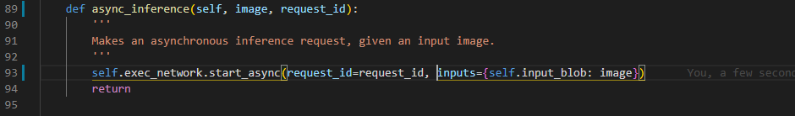

## Write-Up

I have also addressed the areas of the write-up that required additional work.

### Create and explain your method behind comparing the performance of a model with and without the use of the OpenVINO™ Toolkit (accuracy, size, speed, CPU overhead).

#### Also, compare the differences in network needs and costs of using cloud services as opposed to deploying at the edge.

### Explain potential use cases of a people counter app.

#### This should include more than just listing the use cases - explain how they apply to the app, and how they might be useful.

### Discuss lighting, model accuracy, and camera focal length/image size, and the effects these may have on an end user requirement.

#### Try to elaborate a bit more on each point, for example what effects on performance/cost/network bandwidth do these factors have?